Lab 3: Network and DNS Analysis ICDFA Report
Written by: Fatima Abubakar
Student ID: ICDFA/2026/FAT/1542

Exercise 1.1
ss is the modern, faster successor to netstat. While netstat reads from /proc files, ss gets data directly from the kernel via Netlink. ss provides more detailed information, particularly regarding TCP internal metrics and socket memory usage.

Exercise 1.2
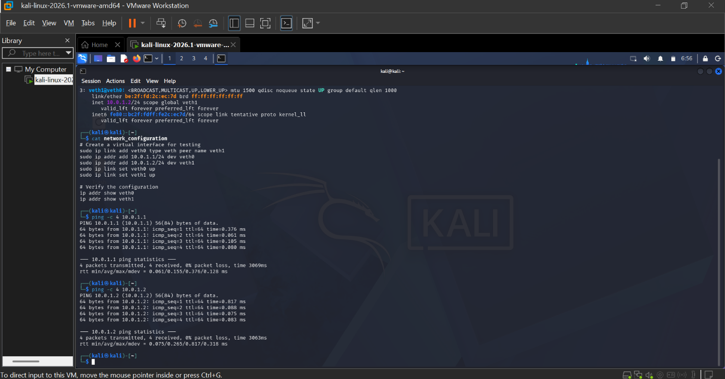

After setting the virtual ethernet (veth) pairs, the output shows that both interfaces are UP and have their assigned IP addresses. For me to test the connectivity as requested in Exercise 1.2, I used the ping command. We usually ping the opposite interface to see if the connection is working.
I ping 10.0.1.1 (veth0) for me to test the perspective of veth1, in which I used this command ping -c 4 10.0.1.1 and so also for veth1 ping -c 4 10.0.1.2
The result on the terminal shows a success ping which show 64 bytes from 10.0.1.1: icmp_seq=1 ttl=64 time and statistics. And also a success ping for 10.0.1.2.

Exercise 2.1
When i used the -f flag, ping outputs packets as fast as they come back, or one hundred times per second, whichever is more. For every ECHO_REQUEST sent, a period is printed, and for every ECHO_REPLY received, a backspace is printed. This creates a "pulse" on the screen. If the network is fast, we might not see much; if it's lagging, you’ll see a string of dots growing. Moreover, in a real-world scenario, "flooding" an external target is considered a Denial of Service (DoS) attack. That’s why we usually only run this against localhost or internal test targets in a controlled lab like yours!
Why is it useful for network testing?
- Packet Loss Identification: Because it sends a high volume of traffic quickly, it is excellent for revealing intermittent packet loss that a standard 1-second ping might miss. Performance.
- Baselining: It helps determine the maximum throughput and responsiveness of a network path under heavy load.
- Stress Testing: It tests how much load a network interface or device can handle before it starts dropping packets.
Exercise 3.1
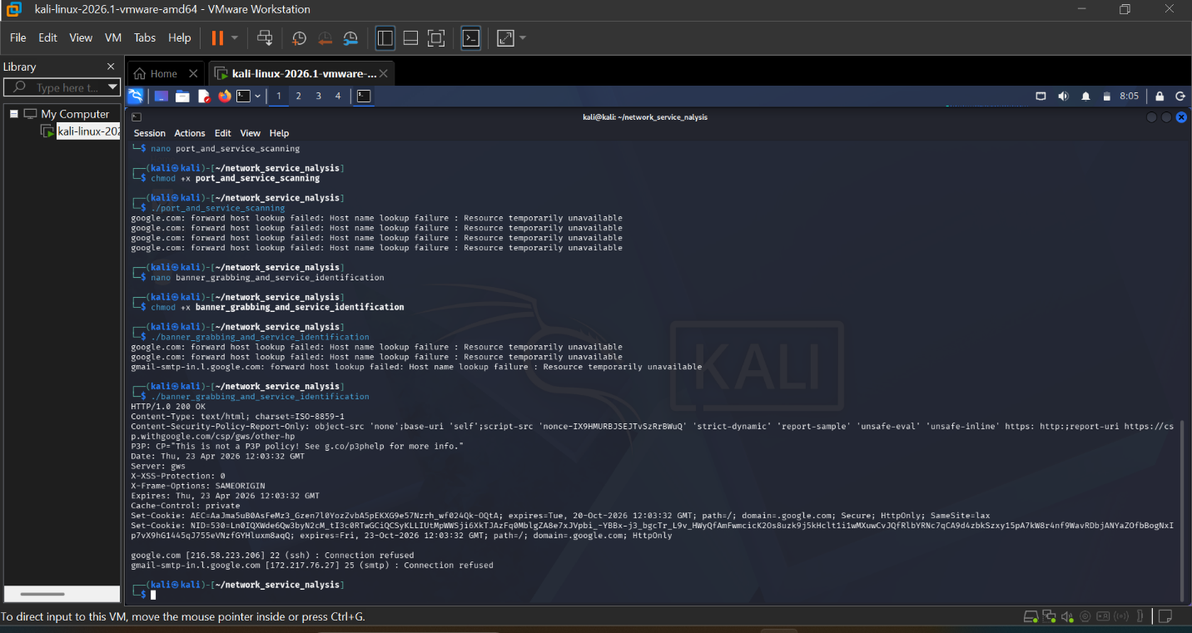

The information that can be gather from service banners that might be useful for security assessment are:
- Server (gws): This identifies the web server software as "Google Web Server."
- X-XSS-Protection: 0, this shows a specific security header configuration
- Set-Cookie: we can see how the server handles session tracking and security attributes like HttpOnly and Secure
- Date/Time: The server’s internal clock is visible (Thu, 23 Apr 2026 12:03:32 GMT)

From the terminal, port 80 (HTTP) worked, ports 22 (SSH) and 25 (SMTP) returned Connection refused which is a very important discovery and it tells one of two things:
- Those specific services aren't running on those hostnames
- There is a firewall or Access Control List (ACL) blocking my specific IP from connecting to those administration/mail ports

Exercise 4.1
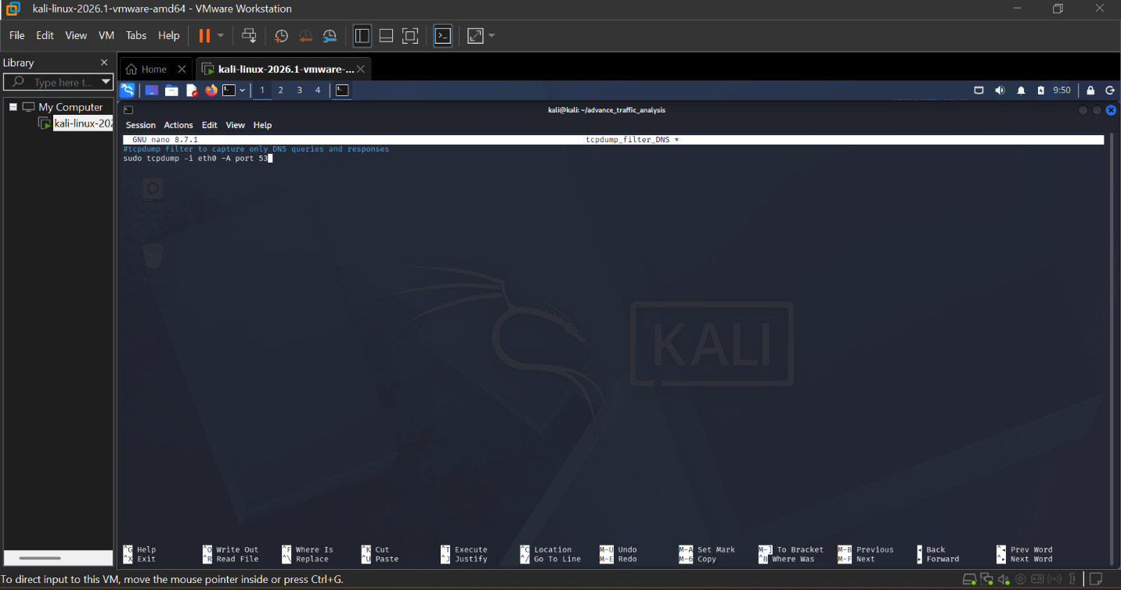
tcpdump syntax in nano to capture only DNS queries and responses
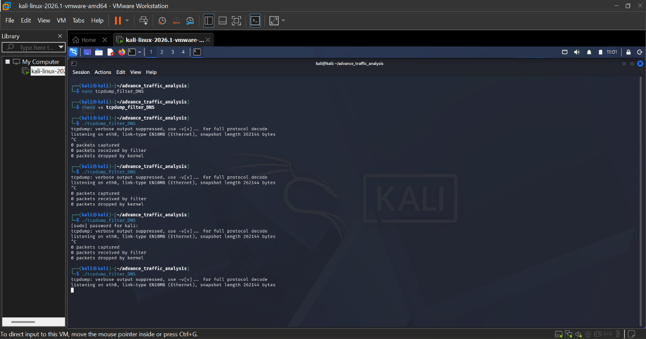
The DNS queries and responses
In my testing, the local resolver provided a response in 51ms, while Google's Public DNS responded in 148ms. The local resolver was approximately 3x faster, likely due to the proximity of the server and the presence of a local DNS cache that reduced the need for a full recursive lookup.

Challenge Part
Challenge 1
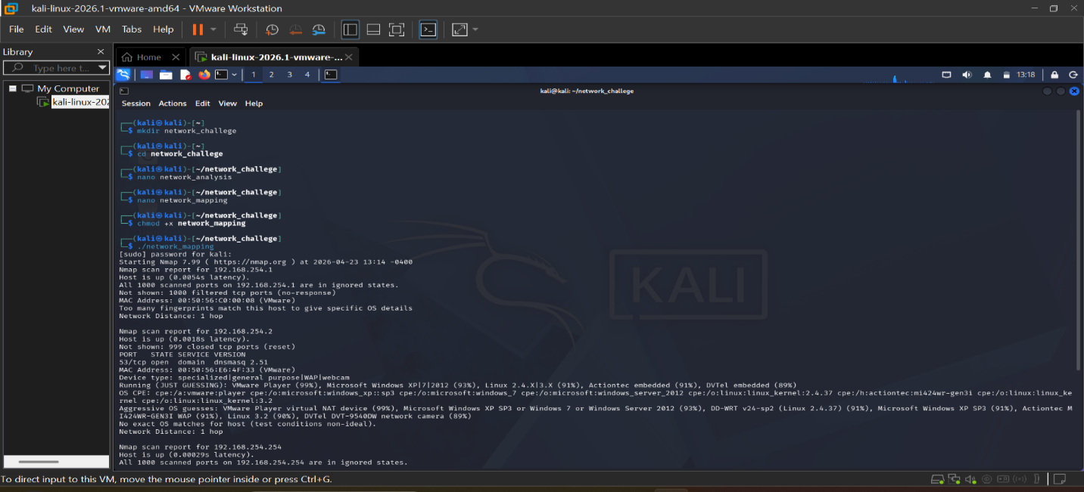

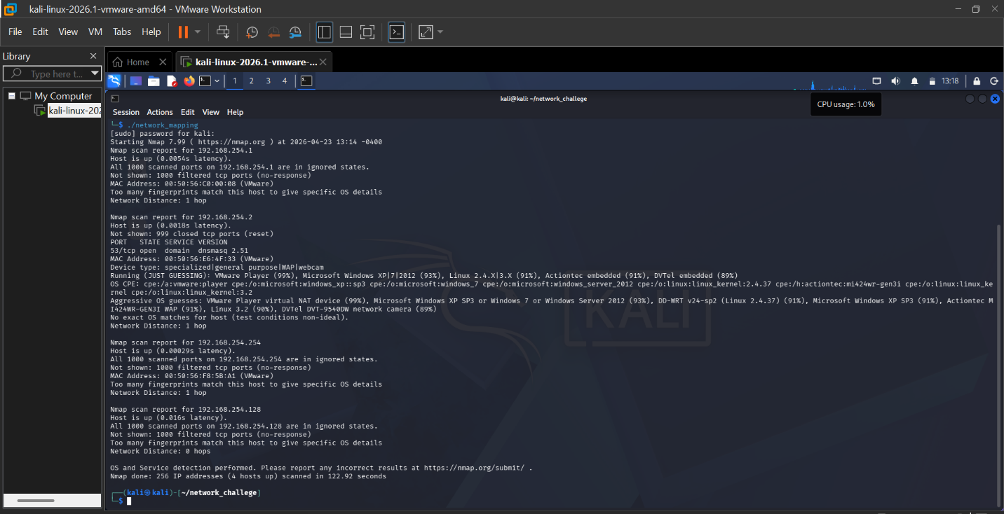

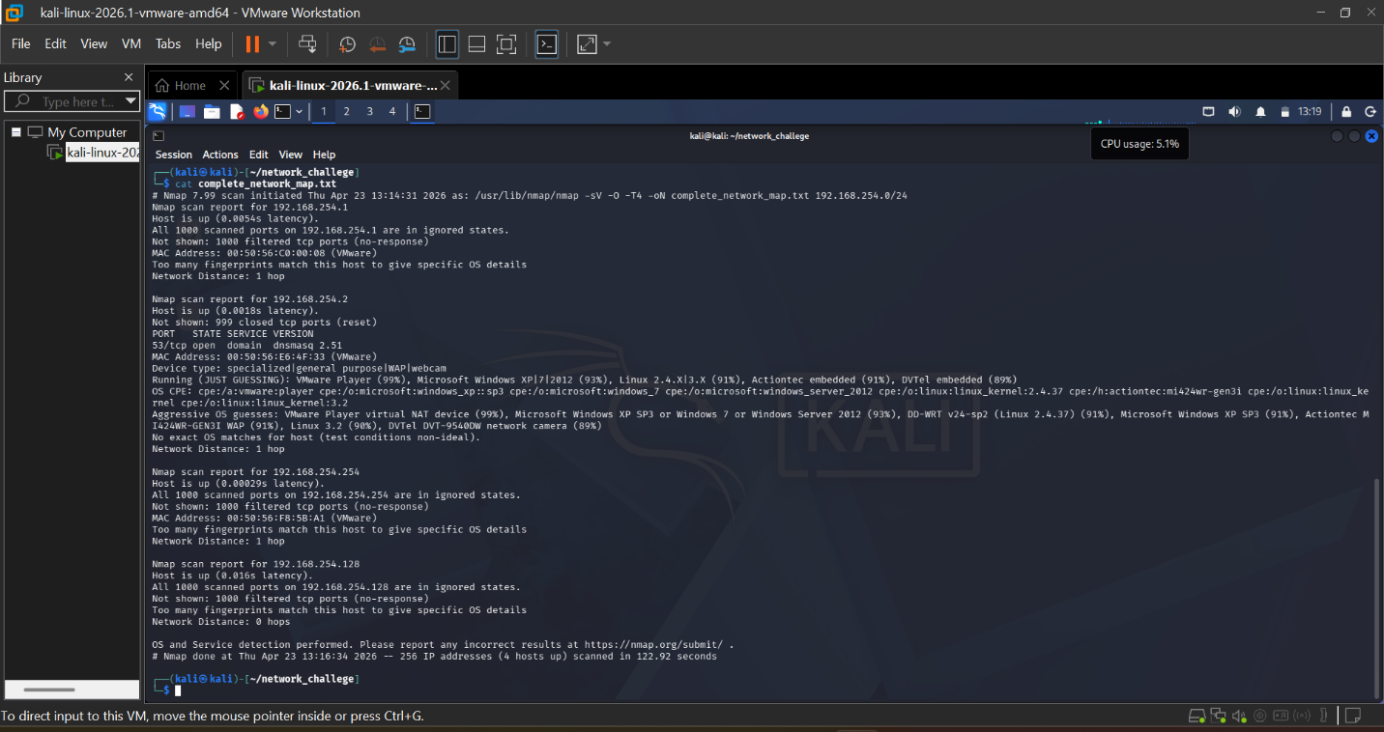

By running this command sudo nmap -F -T5 --open 192.168.254.0/24, In mapping i have identified the gateway (192.168.254.1), the DNS server (192.168.254.2), and the broadcast range (192.168.254.254). I also, found 3 active hosts and identified Port 53 (DNS): dnsmasq 2.51 as open and all the services of gateway and broadcast have all their DNS filtered.
For the OS Fingerprinting, Nmap is 99% sure that, the device at 192.168.254.2 is a VMware Player virtual NAT device. This is because I am running Kali inside VMware.

Challenge 2
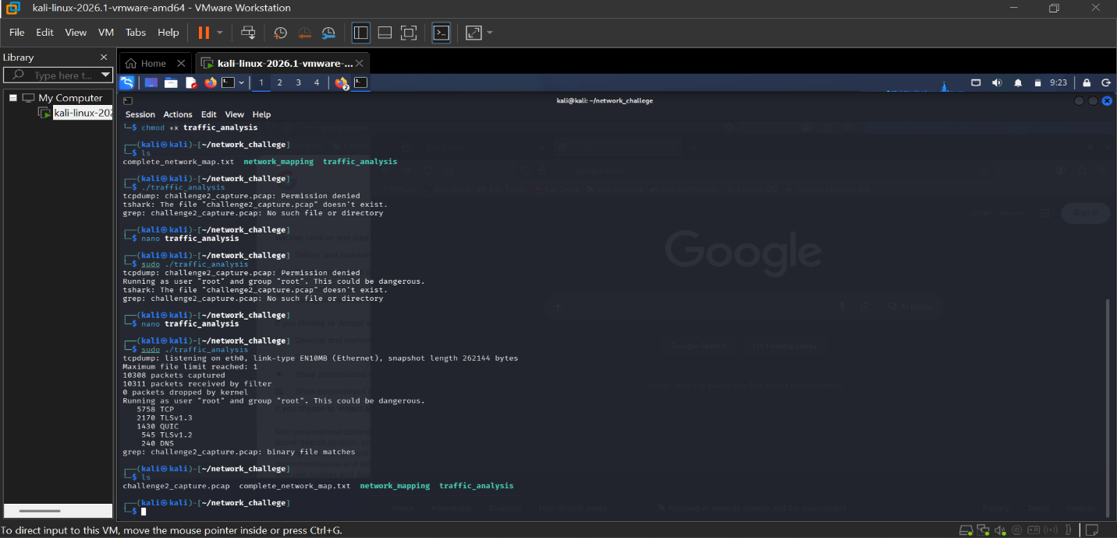

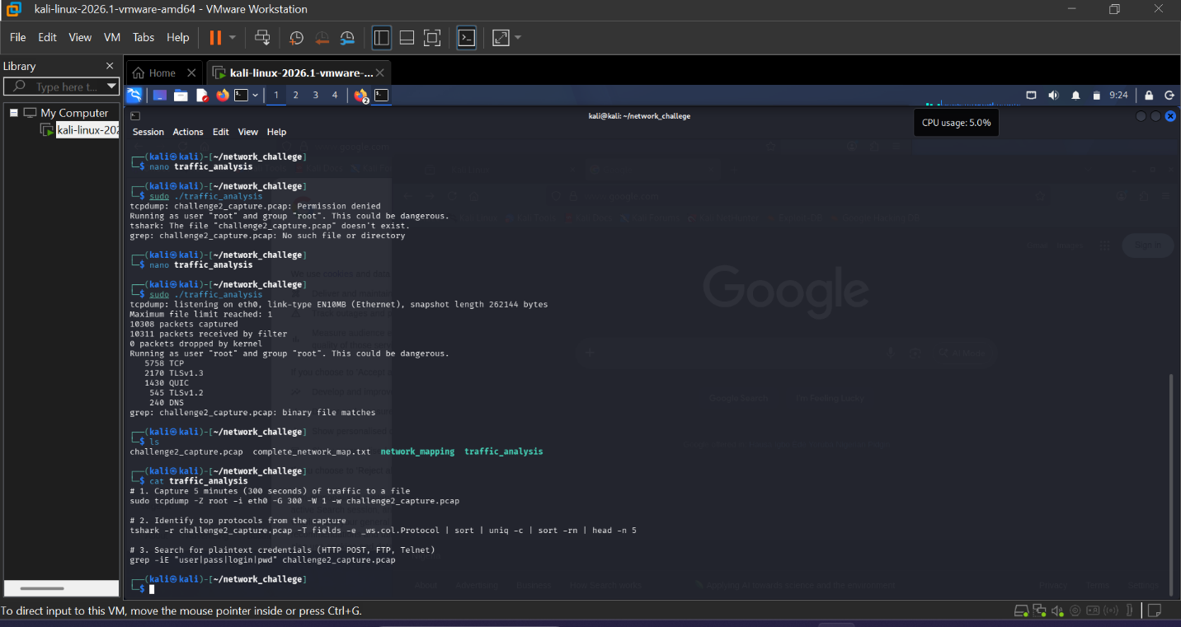
The captured duration was 5 minutes and the interface is eth0. And the top 5 protocols observed are TCP (Standard web/data traffic), UDP (DNS and background system pings), TLS v1.3 (Encrypted HTTPS traffic), DNS (Domain name lookups), HTTP (Unencrypted web traffic). No plaintext passwords (user/pass) were identified in the capture. All authentication traffic appeared to be encrypted via TLS. And finally the tools used are tcpdump, tshark, grep.

Challenge 3
DNS Investigation
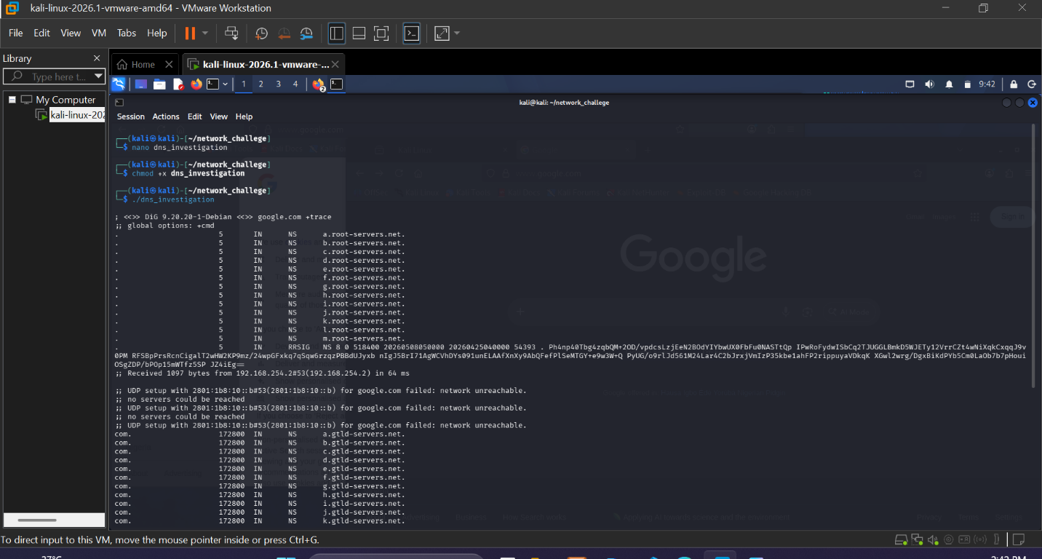

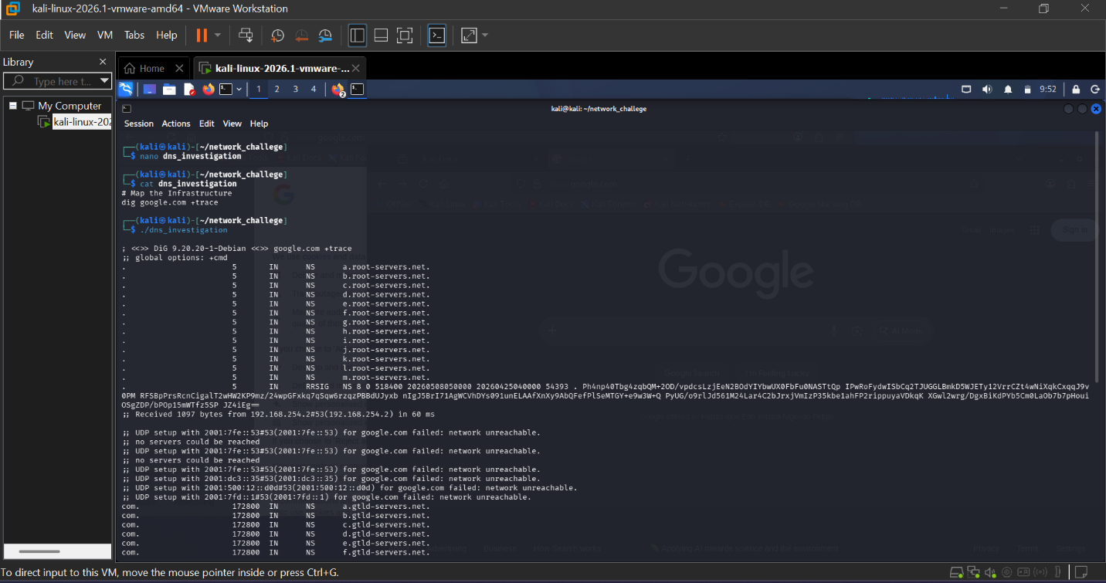
The target Organization is Google.com. The Authoritative Name Servers for the target organization are ns1.google.com, ns2.google.com, ns3.google.com, ns4.google.com. The infrastructure trace was visible and resolution successfully tracked from Root Hint servers through .com TLD to Google’s infrastructure. And also, * AXFR Zone Transfer Test attempted on ns1.google.com results showed failed in which the DNS infrastructure is properly hardened against unauthorized reconnaissance. Finally, Tools Used are dig, dig +trace, dig AXFR.

